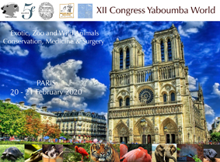

Registration form

Title Name – Surname

Adress

E-mail Phone
Payment by bank transfert

Bank
Société Générale
Name of the holder : Association Yaboumba
Nogent Sur Marne

Bank references :

code banque : 30003 - code agence : 03480
n° account : 00050430200 - RIB : 41

IBAN : FR76 30003 03480 00050430200 41

BIC-ADRESSE SWIFT : SOGEFRPP
Date | Designation | Amount
20- 21  /02/2020 | Full Congress | 0 € (Speakers)  300 € (full price)  120 € (students)  50 € (Yabouma Jr)
19/02/2020  WORKSHOPS | Dentistry in small mammals | 200 €
19/02/2020  WORKSHOPS | Cytology in Exotics | 150 €
19/02/2020  WORKSHOPS | Orthopedics in Birds | 350 €
19/02/2020  WORKSHOPS | Ultrasound in Reptiles | 300 €
19/02/2020  WORKSHOPS | Endoscopy in Birds | 350 €
19/02/2020  WORKSHOPS | Cystoscopy Reptiles | 300 €
21 / 02/ 2020 | DANCE PARTY | 40 €

Sent to : Norin CHAI, Ménagerie du Jardin des Plantes
57 rue Cuvier 75005 PARIS – France
or by email : norin.chai@mnhn.fr

